Experiences and lessons managing water in Cape Town with the advent of ‘Day Zero’
Robbie Parks, Megan McLaren, Ralf Toumi, Ulrike Rivett
Outline
Introduction (IMPERIAL)
- ‘Water is a natural resource that is embedded in the cultural and religious values of societies. It is what we take pictures or create paintings of. It is why we construct fountains.’¹
- Hydrological drought is associated with precipitation shortage on a longer time scale (12 months to 2 years or more).

- The challenge of water management and drought globally

Importance of good water management
- Demand for water is growing, both due to population increases, changing diets, as well as changes in the way people aspire to use water.
- ‘There are many regions where our freshwater resources are inadequate to meet domestic, economic development and environmental needs’¹
- ‘In recent decades the percentage increase in water use on a global scale has exceeded twice that of population growth’¹
- ‘1 of every 6 units of water treated across the United States never reaches the consumer.’²

Globalization of water
- ‘Virtual water’ is the water used in production of a commodity (e.g. food), produced locally to then be exported around the world. This affects local real water supplies.³

Changing supply and demand patterns due to climate change

Growing urban demand
- ‘Urban water demand will increase by 80% by 2050, while climate change will alter the timing and distribution of water’.⁴
- More than 27% of cities studied, containing 233 million people, will have water demands that exceed surface-water availability⁴

Freshwater stress
- ‘Adaptation to global change must include prudent management of groundwater as a renewable, but slow-feedback resource in most cases. Groundwater storage is already over-tapped in many regions, yet available subsurface storage may be a key to meeting the combined demands of agriculture, industry, municipal and domestic water supply…’⁵
- ‘The highest vulnerabilities are found at the North African rim of the Mediterranean Sea, in southwestern Africa, in northeastern Brazil and in the central Andes, which are areas of moderate to high sensitivity.’⁶
- ‘Groundwater—the world’s largest freshwater resource—is critically important for irrigated agriculture and hence for global food security’.⁷

Monitoring use/new technologies
- Give a brief taste of where it’s going in section 3…
- Overview of water and drought in Cape Town and South Africa

South Africa
- High drought frequency but relatively low intensity.⁸
- ‘Drought is a regular feature of the South African climate’.⁹
- Drought strongly driven by ENSO and SST anomalies in Indian and South Atlantic Oceans.¹⁰
- No clear trend in precipitation over the past 3 decades.¹⁰
- Studies of the normalised vegetation index dataset (Los et al., 1994) show that the impact of droughts on vegetation (Farrar et al., 1994) is particularly strong where annual rainfall amount varies from 300 to 500 mm (Richard and Poccard, 1998). This is the case for most of South Africa.⁹
- Fig:2 Global urban water security (n=482).⁴
Cape Town
- Total precipitation 749mm per year.¹⁰
- Highest precipitation in June/July/August.
- Opposite precipitation pattern to inland and east part of country.
- Water usage before Day Zero was around 60% of Capetonians using more than 87 litres per day. (link)

- Usefulness of Cape Town as an example of an industrialised city in a semi-developing country
- Overview of sustainable development goals:¹¹
      - 6: Clean water and sanitation
      - 11: Sustainable cities and communities
      - 12: Responsible consumption and production
- Statistical comparison:¹² (to London/NYC/Sydney/Tokyo/Berlin/Paris etc.)
      - GDP per capita: R76 420 (£4,307)
      - GDP annual growth rate ~3.7% a year
      - Main industries: Finance and insurance largest contributor to growth rate
      - Urbanisation: rapid urban growth (statistic?)
      - Population: 4,131,729 by 2020
      - South Africa is one of the most inequitable countries in the world, with a 2014 Gini coefficient of 0.64. South Africa is slightly lower at 0.62 (comparison of UK/London/NYC/Tokyo etc.)

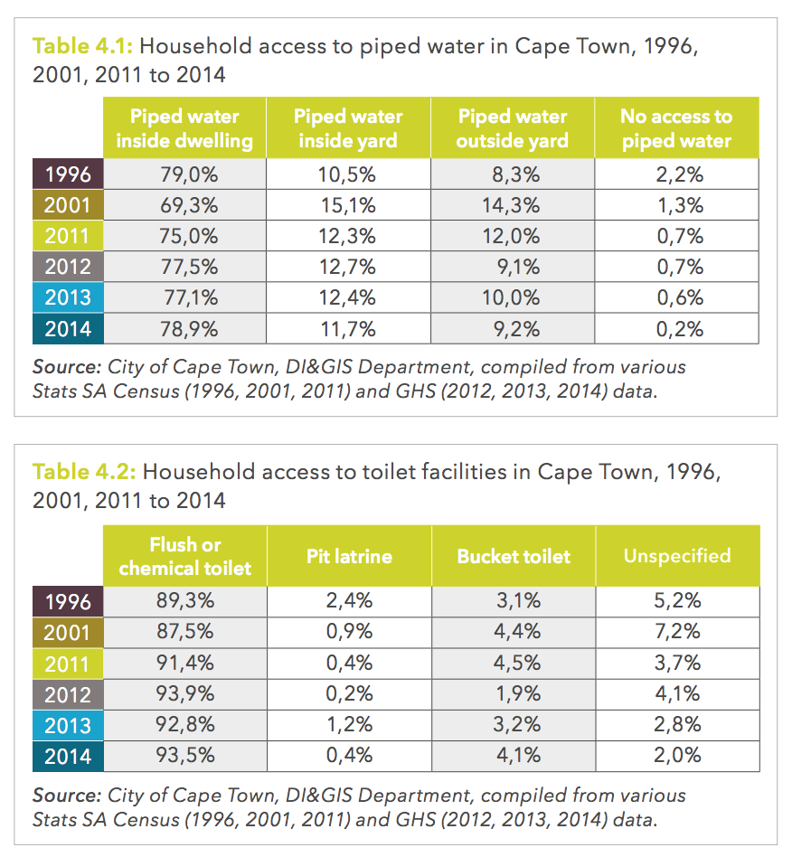

- Comparison of water footprints of Cape Town and other industrialised cities¹³¹⁴

- Water guarantee in the South African constitution
- ‘Section 27: the rights to food, water, health care and social assistance, which the state must progressively realise within the limits of its resources’.¹⁵

- Main supplies and uses of water in South Africa and Cape Town
    - Governance of water supplies
- Clash between political parties and local and national governance. Political squabbling.
- Declaring a particular drought as a disaster having political and management consequences.
    - Overview of surface water
    - Rainfall in South
- Strong inter-annual variability rainfall variability since 1970.⁹
- Total rainfall in Cape Town per year 749mm⁹
    - Uses of water in South Africa and Cape Town
- South Africa stats below:
      - Explanation of blue/green/grey water: http://waterfootprint.org/en/water-footprint/what-is-water-footprint/
      - https://businesstech.co.za/news/general/104441/who-is-using-all-the-water-in-south-africa/

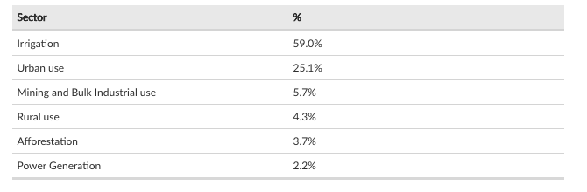

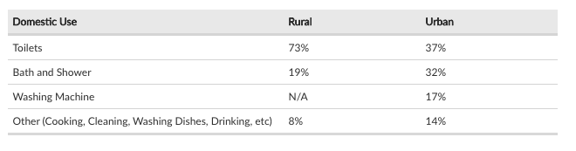

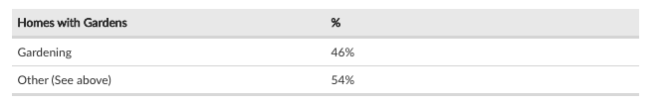
- Cape Town stats below:
  - Formal housing compared with informal settlements
  - Much much less water in informal settlements, although the vast majority of population.
  - While most people are living from taps, richest section using most do not actually do this and so are the ones experiencing rationing for the first time

Why is Cape Town experiencing drought? (IMPERIAL)
- Weather and climate context in South Africa

Based on results of AR5 GCM and sea level change projections.
- Climate zones
- Diverse climate largely influenced by variations in elevation; humid regions influenced by Indian Ocean in south-east are where sub-tropical climate is. Cape region (i.e. around Cape Town), Mediterranean climate conditions occur. Inland exists semi-arid and arid climates.¹⁰
- Temperature
- Temperatures up to and over 32 in summer months and can be below zero in winter months at higher elevations in winter.¹⁰
- Cape Town annual mean temperature 16.1C.¹⁰
- Cold Benguela current along west coast keeps it slightly cooler than east coast (difference of about 5C).¹⁰
- Mean annual temperature has been increasing at 0.14C per decade over the last 30 years.¹⁰
- End-of-century warming in range of 1.7 to 4.7C compared to 1971-2000 reference period.¹⁰
- Precipitation
- South Africa experiences rainy season from convective rainfall in summer months (mid-October to mid-February).¹⁰
- Southwest region, including Cape Town, obtains mid-latitude frontal precipitation during winter.
- No substantial change in precipitation observed over past 113 years of data.¹⁰
- Predicted weak likely range of change in annual total precipitation from -9 to 0 % by 2018 with medium confidence.¹⁰
- Low scenario gives median change of -3% by 2085, high scenario -7%.¹⁰
- Below 2C target is -11 to +2% with above 4C threshold at -17 to -1%.¹⁰
- Drought
- Weak change in duration of long-lasting dry spells increasing by +1 to +3 days by 2085 with a medium confidence.¹⁰
- Low scenario gives median change of +1 day by 2085, high scenario +3 days.¹⁰
- Below 2C target is 0 to 3 days with above 4C threshold at -+1 to +6 days¹⁰
- Water balance
- Medium-strong change with likely range from -46 to +14mm/yr by 2085 at low confidence.
- Below 2C target is -33 to +32mm/yr with above 4C threshold at -71 to +38mm/yr.¹⁰
- Sea-level rise
- Sea rise by end of century by Cape Town in range of +0.44-+0.98m. ¹⁰

- What is ‘Day Zero’ and what happens?
- How was Day Zero defined?
- Defined by City of Cape Town as when dam levels falling below 13.5% of total capacity. (link)
- Point at which Disaster Risk Management Centre introduces phase 2 of its plan.
- Phase 2 is a ‘desperate bid’ to avoid Phase 3, where there is no more surface water supply. At that point, bottled water from
- Not a fixed day. Has moved from April 12 to July 9 and in fact was never reached in the end. (link)
- Full-Scale Emergency Stage 3 was for months, from 3-6 months.
- What would have happened from Day Zero?
- Residents will have to stand in line to collect 25 litres of water per person per day (link), in line with WHO recommendations.
- Most taps will have turned off, leaving only vital services with access to water.
- Informal settlements with majority of densely populated informal settlements will remain linked
- Schools will close, along with most businesses, unless they possess their own bore holes and temporary off-mains toilets and drinking water.
- Alternative sources groundwater, desalination explored.
- Level 6B water restrictions was 450 million litres per day, or 50 litres per person occurred by Feb 1st.

- Overview of Cape Town’s seasonal water cycle and supply
- https://citymaps.capetown.gov.za/waterviewer/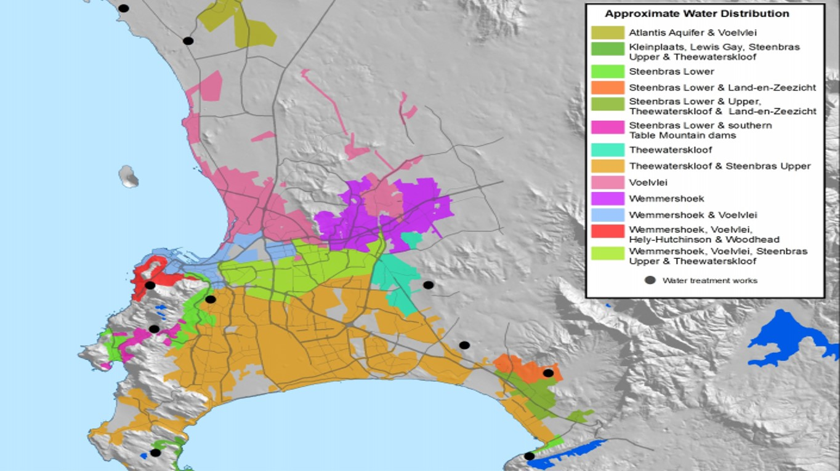

(http://www.thewatershedproject.co.za/wp-content/uploads/2015/05/Where-does-my-water-come-from-1.jpg)
- City has six big dams as sources of water. (link)

- Threats to water supply under climate change
- Change in annual precipitation by 2100 in range of -9 to 0% (compared with 1971-2000).¹⁰
- Projections also suggest more intense rainfall events followed by prolonged duration of dry spells. No clear trend on frequency of heavy rainfall events.¹⁰

How did the possibility of drought impact Cape Town? (IMPERIAL/UCT)

Management and rationing of water

Social and behavioural impacts

Health impacts

Economic impacts

Differential of impacts on different strata of society (rich/poor/black/white)

How is Cape Town adapting to its new reality? (UCT)

Early Warning Systems of drought

Water proliferation technology, what works and what doesn’t

Monitoring water use

Increasing transparency of existing water usage data

Political ramifications of drought

Policy recommendations (IMPERIAL/UCT)

Lessons learnt
- Importance of political harmonisation of drought

What works and what doesn’t

Technological recommendations

Social policy recommendations

How to engender long-lasting behavioural change

Relevance to other places in the world

Bibliography
1 Cosgrove WJ, Loucks DP. Water management: Current and future challenges and research directions. Water Resour. Res. 2015; 51: 4823–39.
2 Chini CM, Stillwell AS. The State of U.S. Urban Water: Data and the Energy-Water Nexus. Water Resour. Res. 2018. DOI:10.1002/2017WR022265.
3 Hoekstra AY, Hung PQ. Globalisation of water resources: International virtual water flows in relation to crop trade. Glob Environ Chang 2005; 15: 45–56.
4 Flörke M, Schneider C, McDonald RI. Water competition between cities and agriculture driven by climate change and urban growth. Nat Sustain 2018; 1: 51–8.
5 Green TR, Taniguchi M, Kooi H, et al. Beneath the surface of global change: Impacts of climate change on groundwater. J. Hydrol. 2011; 405: 532–60.
6 Doell P. Vulnerability to the impact of climate change on renewable groundwater resources: A global-scale assessment. Environ Res Lett 2009; 4. DOI:10.1088/1748-9326/4/3/035006.
7 Aeschbach-Hertig W, Gleeson T. Regional strategies for the accelerating global problem of groundwater depletion. Nat. Geosci. 2012; 5: 853–61.
8 Spinoni J, Naumann G, Carrao H, Barbosa P, Vogt J. World drought frequency, duration, and severity for 1951-2010. Int J Climatol 2014; 34: 2792–804.
9 Rouault M, Richard Y. Intensity and spatial extension of drought in South Africa at different time scales. Water SA 2003; 29: 489–500.
10 Climate Service Center Germany (GERICS). South Africa Climate-Fact-Sheet. 2015; : 1–8.
11 Griggs D, Stafford-Smith M, Gaffney O, et al. Sustainable development goals for people and planet. Nature 2013; 495: 305–7.
12 City of Cape Town. State of Cape Town Report 2016. 2016; : 79.
13 Hoekstra AY, Chapagain AK. Water footprints of nations: Water use by people as a function of their consumption pattern. In: Integrated Assessment of Water Resources and Global Change: A North-South Analysis. 2007: 35–48.
14 Hoff H, Döll P, Fader M, Gerten D, Hauser S, Siebert S. Water footprints of cities - Indicators for sustainable consumption and production. Hydrol Earth Syst Sci 2014; 18: 213–26.
15 Republic of South Africa. Constitution of the Republic of South Africa, Act 108 of 1996. 1996.

